Amazon AWS Account:

Step 1:

Go to <https://aws.amazon.com> .

Click on Create an AWS Account Button.

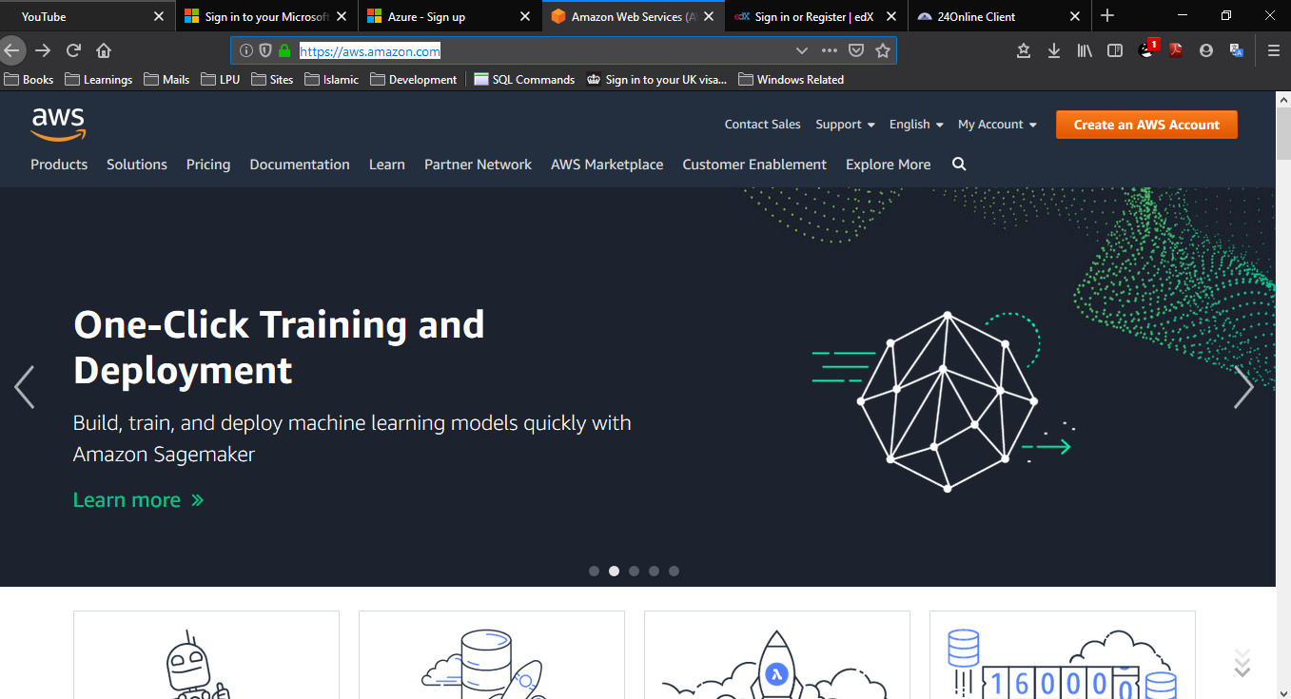

Step 2:

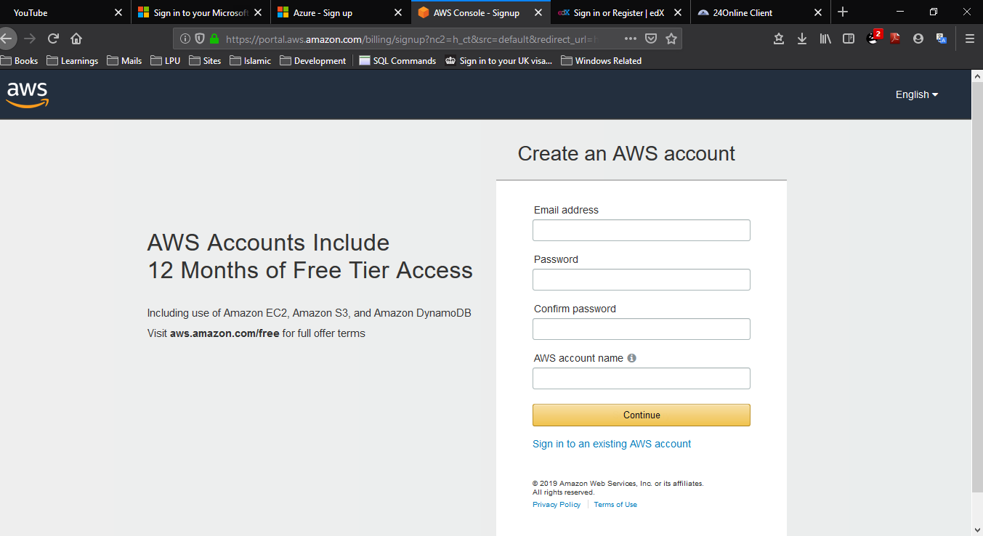

Step 3:

Fill the AWS Create Account Form.

Click ON Create Button.

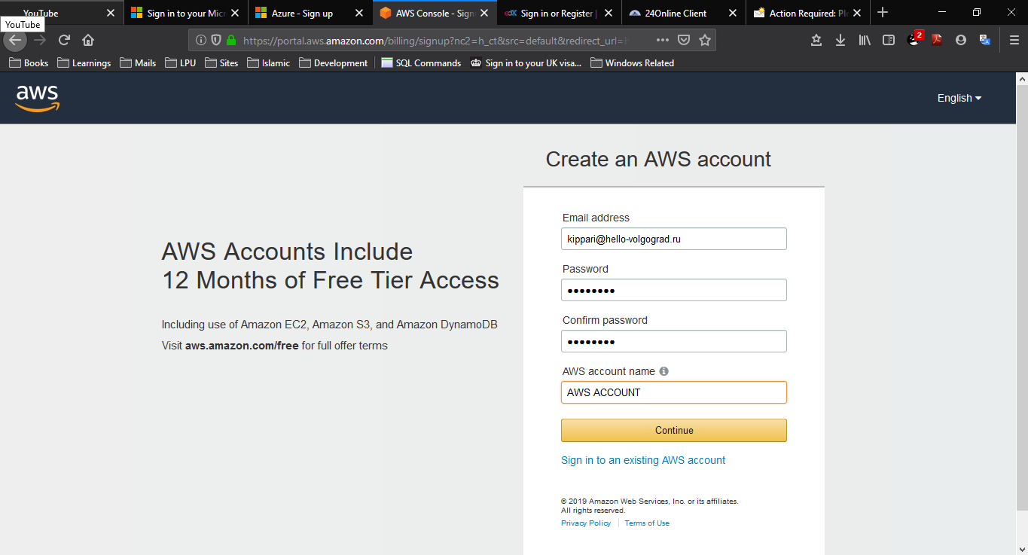

Step 4:

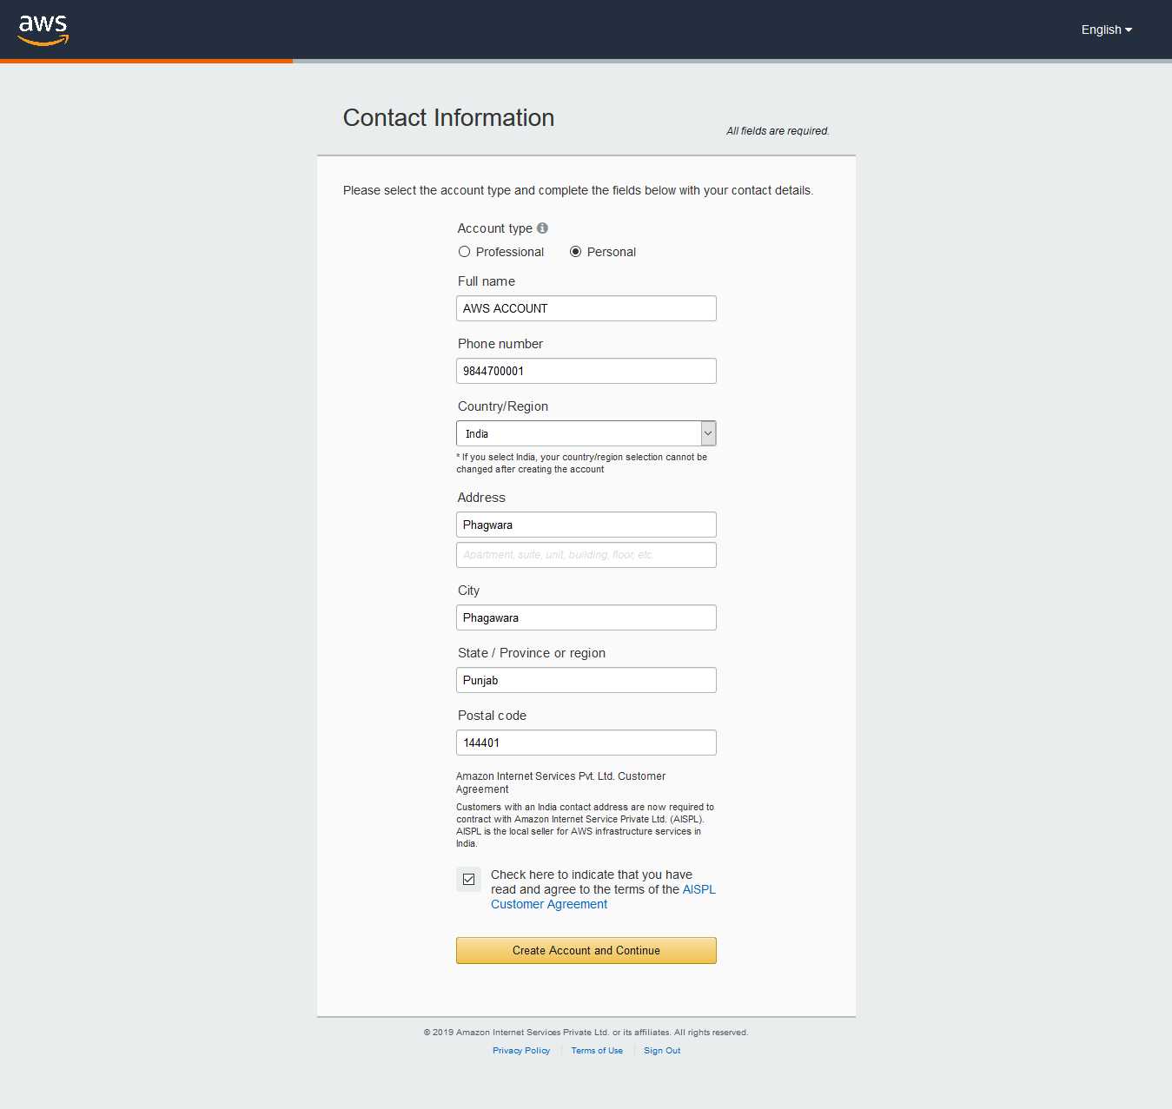Select Personal Account Type in Contact Information Page and fill the details.

Step 5:

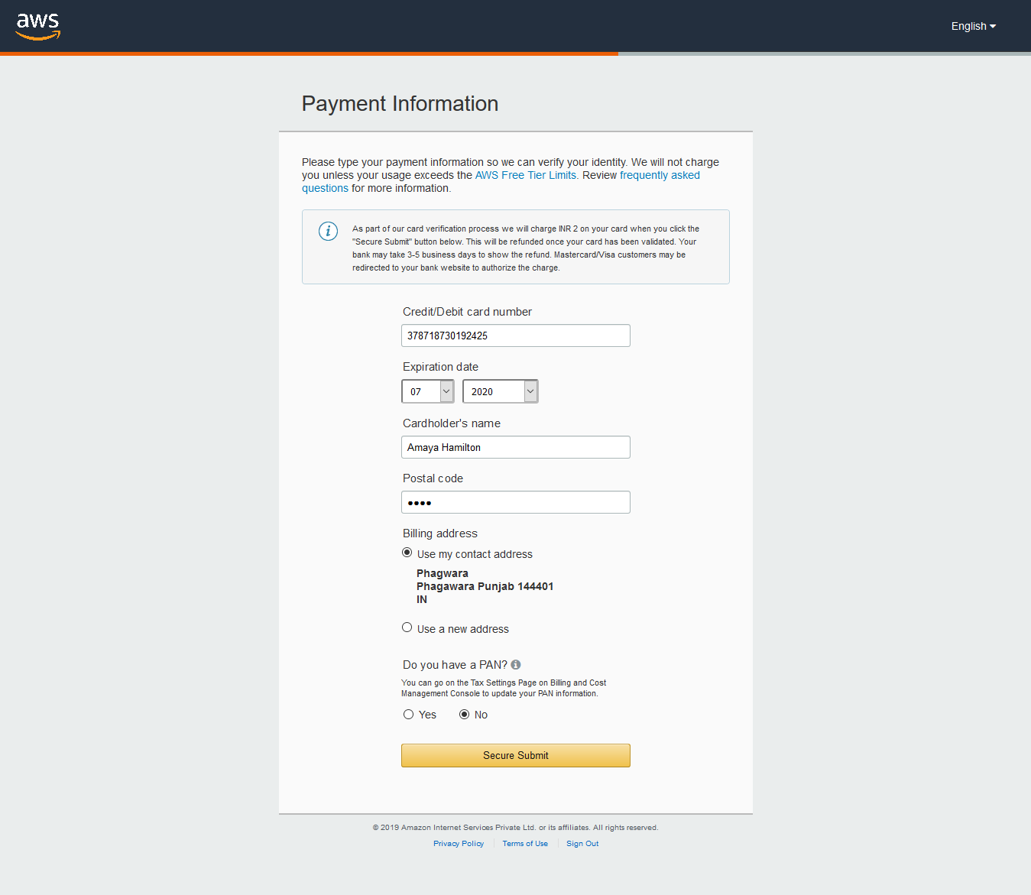Enter the Payment Information.

Step 6:

Confirm your identity by entering Cell Phone Number.

Click Send Sms Button.

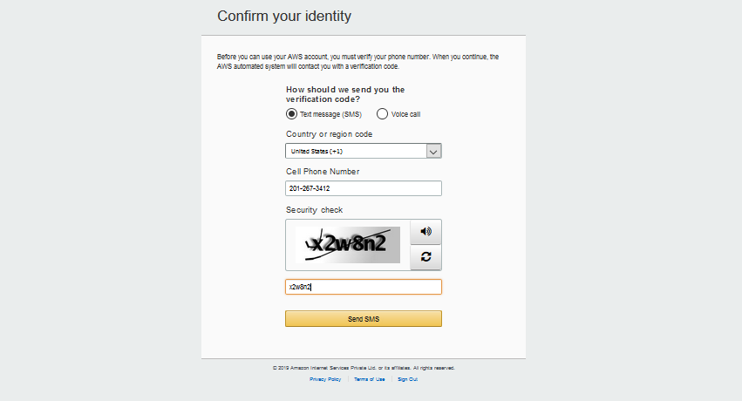

Step7:

Press Continue Button to Continue.

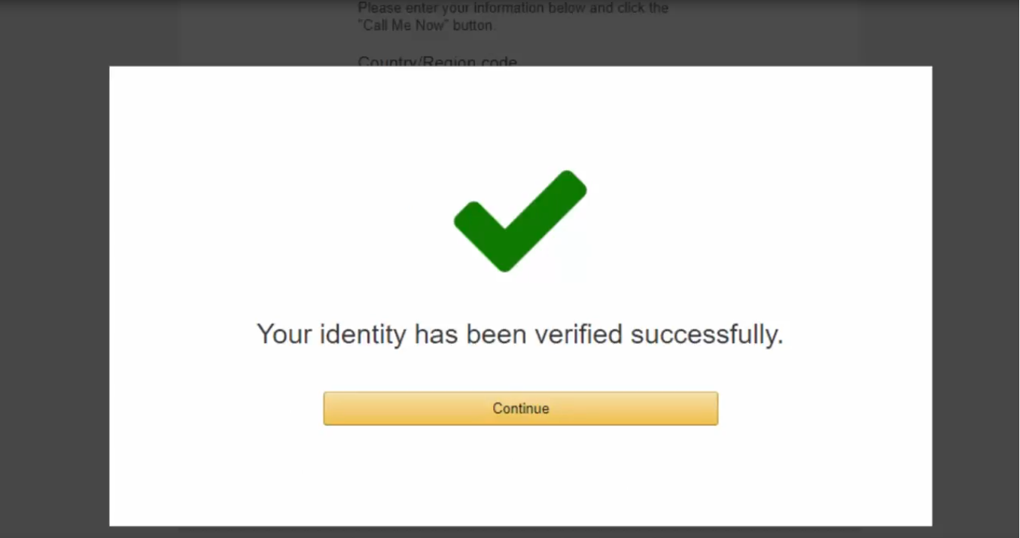

Step 8:

Log in into your AWS account.

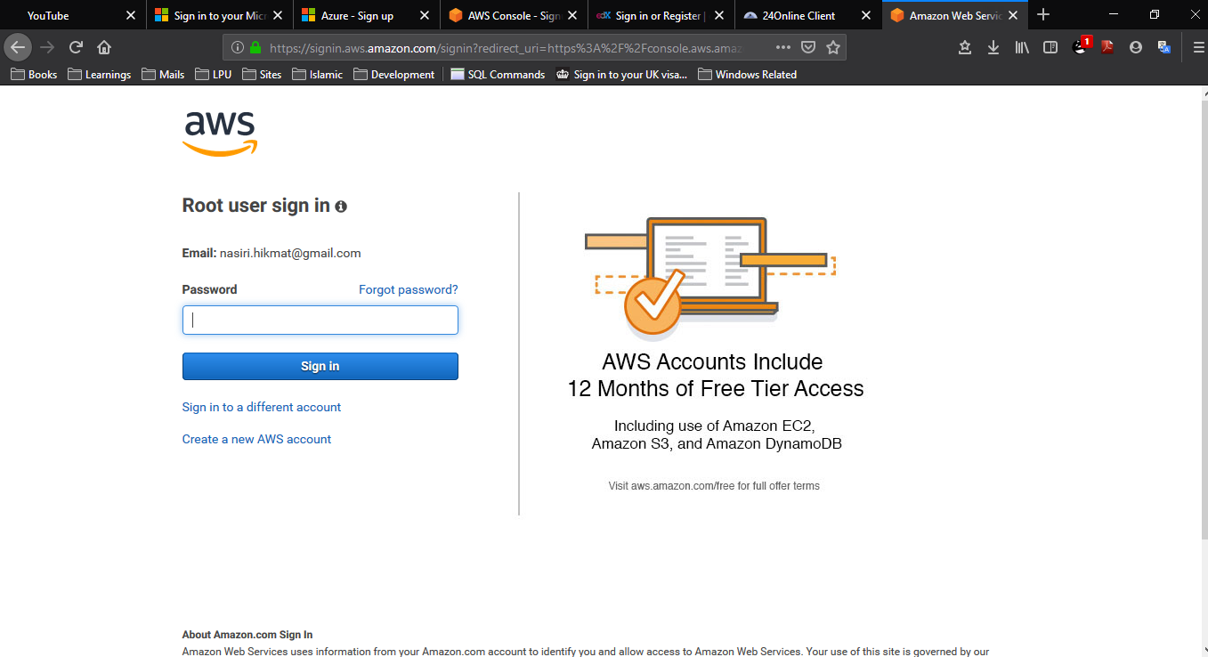

Step 9:

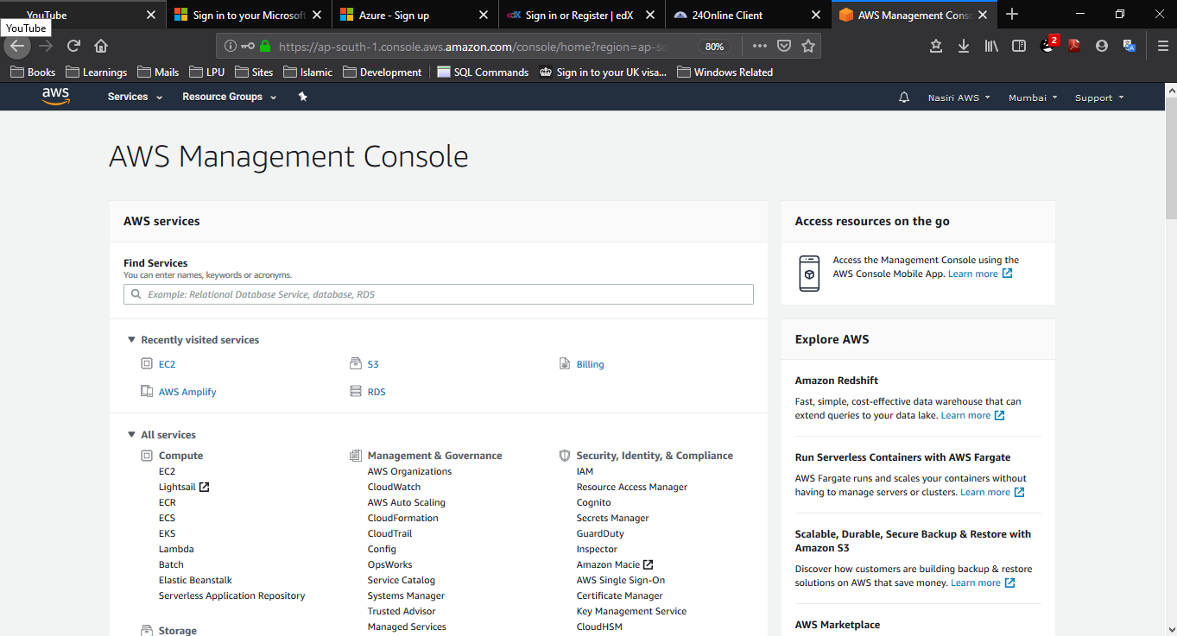Welcome to AWS Management Console.